Capstone Project for Crop Recommendation Final report

1.Dataset Name Crop_recommendation from Kaggle as csv file

2.In this dataset input -N(Nitrogen),P(phosphorous),K(Potassium),temperature,humidity,ph,rainfall

Output-label

3.in this data output has categorical data,so we go to ML Classification Analysis

4.Temperature,humidity,ph has high VIF correlation value . so we avoide multicollinearity we take onlyN,P,K,rainfall.

5.In Feature selection –chai’s value for classification RandomForest has 0.990909

6. In RFE value for Random forest has 0.989091

7.According to featureselection,I select RandomForestClassification Model as final model

And get the accuracy value is 0.930303

8.Due to this above accuracy 0.930303 I did GridSearchCV ConfusionMatrix

Through Heatmap get Accuracy 93.03%

9.From univariate analysis I submitted without outliers descriptive column

10.In Bivariate analysis I submitted pairplot using seaborn library

11.I finalized the model and save the model.

12.Finally Deployment is done and predict the output and call to action

I submitted all related ipython Notebook files in gitup

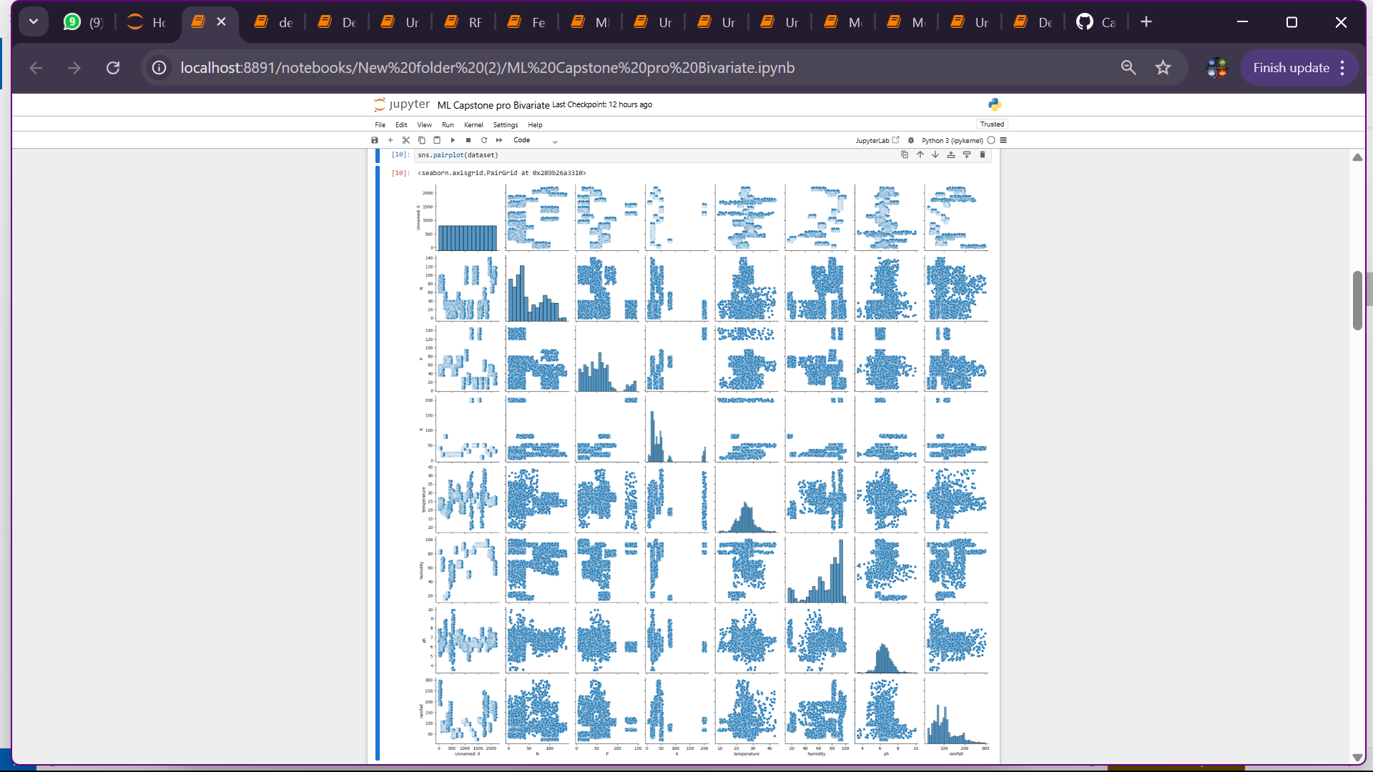

o